Section 4.1 Additive, Multiplicative, and Ciphered Systems of Numeration
The number system most of the world uses today, called the Hindu-Arabic system, is only one way to communicate numerically. We will study how to perform basic arithmetic in other bases and with methods other than those most of us were taught when we were children.

Systems of Numeration: Consists of a set of numerals and a scheme or rule for combining the numerals to represent numbers.

Four types of numeration systems we will cover are used by different cultures: Additive (or repetitive), Multiplicative, Ciphered, and Place-Value Systems. You do not need to memorize all the symbols, but you should understand the principles behind each system. By the end of this chapter, you should have a better understanding of the system we use, the Hindu-Arabic system.

- Additive Systems: A system in which the number represented by a set of numerals is simply the sum of the values of the numerals [one of the oldest and most primitive types of numeration systems].

  - Egyptian Hieroglyphic System (approx. 3,000 B.C.) Used symbols powers of 10.
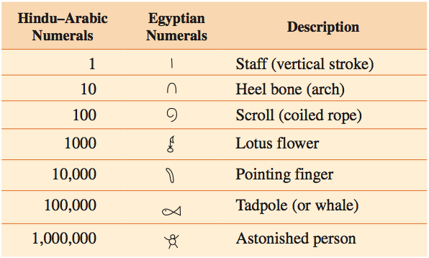
Note: No symbol for zero.
Example 1: Write the following as a Hindu-Arabic Numeral: 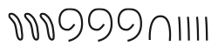

Example 2: Write 1,203,462 as Egyptian numerals:

In the Egyptian hieroglyphic system, the order of the symbols is not important.
Users of additive systems easily accomplished addition and subtraction by combining or removing symbols. Multiplication and division were more difficult; they were performed by a process called duplation and mediation (see Section 4.5). The Egyptians had no symbol for zero, but they did have an understanding of fractions.

  - Roman Numerator System: Used in most European countries until the 18th Century.

Hindu-Arabic | 1 | 5 | 10 | 50 | 100 | 500 | 1000
Roman Numerals | I | V | X | L | C | D | M

Two advantages over Egyptian system:
- Roman Numerator System uses the subtraction principle as well as addition principle. Starting from the left, we add each numeral unless its value is smaller than the value of the numeral to its right. In that case, we subtract its value from the value of the numeral to its right.
DC | = |  | CD | =
 | = |  |  | =
 | = |  |  | =

Subtractive Combination rule:
- Only I, X, and C can be used as the leading numeral in part of a subtractive pair.
- I can only be placed before V and X.
- X can only be placed before L and C
- C can only be placed before D and M.
Higher denominations preferred & Minimum numbers
9 IX versus VIV
- Symbols are not repeated more than 3 times.

- Uses the multiplication principle for numerals greater than 1000
$$\overline{v}=$$
$$\overline{CD } =$$

Example 3: Write MCCLXXXI as a Hindu-Arabic Numeral:
MCCLXXXI =

Example 4: Write CMLXIV as a Hindu-Arabic Numeral:

Example 5: Write 439 as a Roman Numeral:

Example 6: Write 12,345 as a Roman Numeral:

- Multiplicative Systems: More similar to the Hindu-Arabic system which we use today.

Traditional Chinese Numerals:
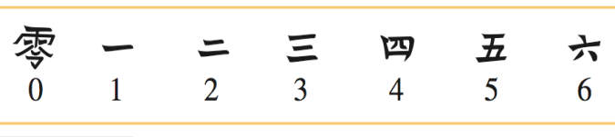
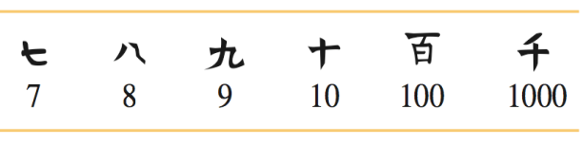

Note: Always written vertically, highest # on top, lowest on bottom.

Top numeral from 1-9 inclusive

20 = 24 =

400 = 427 =

Example 7: Write 538 as a Chinese Numeral

Note:
- When writing traditional Chinese numerals, the units digit is never multiplied by a power of the base.
- When writing a numeral between 11 and 19 it is not necessary to include the 1 before the 10. (see Example below, then try to write 13 as a Chinese Numeral)

Example 8: Write 18 as a Chinese Numeral

Note: When more than one consecutive zero occurs (except at the end of numeral) you need to write a zero, but only once for two or more consecutive zeros. Zeros are not included at the end of numerals.

Example 9: Write 7080 & 7008 as a Chinese Numeral

7080 = | 7008 =

- Ciphered Systems: There are numerals for numbers up to and including the base and for multiples of the base. The number (amount) represented by a specific set of numerals is the sum of the values of the numerals. Ciphered numeration systems require the memorization of many different symbols but have the advantage that numbers can be written in a compact form.

Ionic Greek System
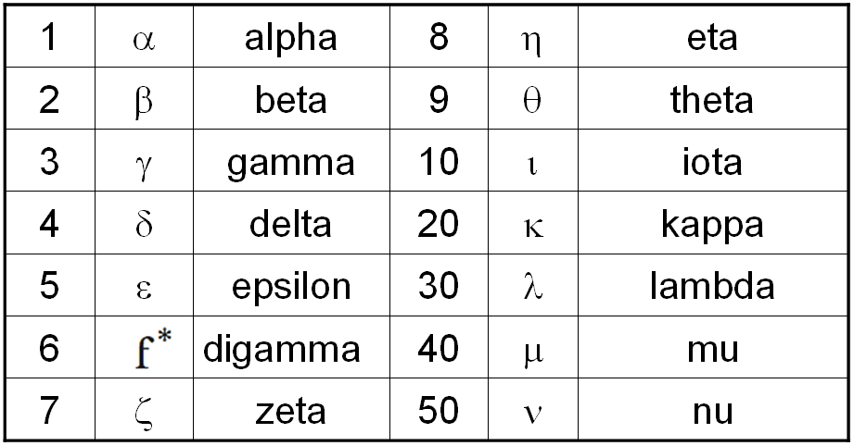
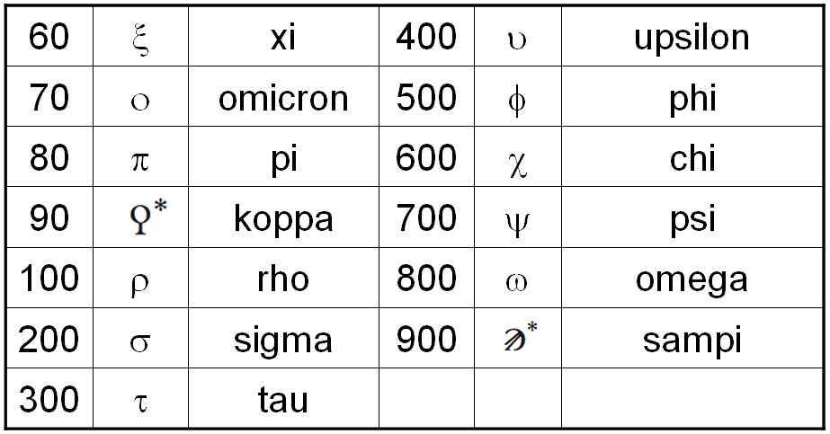

* Ancient Greek letters not used in the classic or modern Greek language.
Example 10: Write $τπε$ as a Hindu-Arabic numeral.

Example 11: Write ψλθ as a Hindu-Arabic numeral.

Note: An iota, ɩ, placed to the left and above a numeral, represents the numeral multiplied by 1000.

Example 12: Write 1654 as an Ionic Greek numeral.

Example 13: Write 45 as an Ionic Greek numeral.

Example 14: Write 768 as an Ionic Greek numeral

